|  |  |  |  |
| --- | --- | --- | --- |
| **Skin images** | **Original images** | **Final segmented lesion binary images** | **Calculated Dice Similarity value** |
| **ISIC_0000019** | **C:\Users\Computing\Desktop\0000019.PNG** | **C:\Users\Computing\Desktop\19.PNG** | **0.8423** |
| **ISIC_0000095** | **C:\Users\Computing\Desktop\0000095.PNG** | **C:\Users\Computing\Desktop\95.PNG** | **0.6421** |
| ISIC_0000214 | **C:\Users\Computing\Desktop\0000214.PNG** | **C:\Users\Computing\Desktop\214.PNG** | **0.8728** |

**Fig 1: Three Skin Images for ISIC_0000019, ISIC_0000095, and ISIC_0000214,**

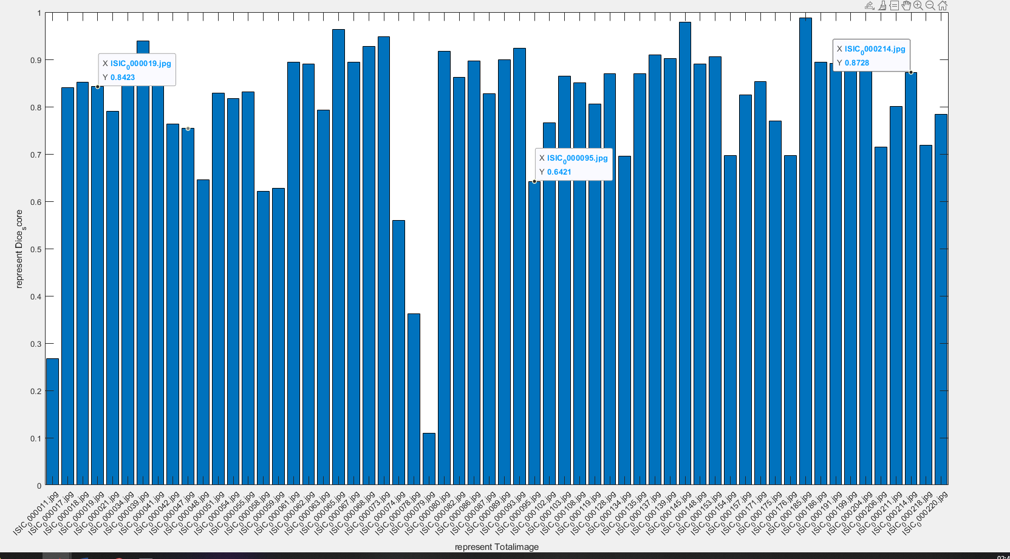

**Fig 2: Number of Image versus Dice Similarity Scor**

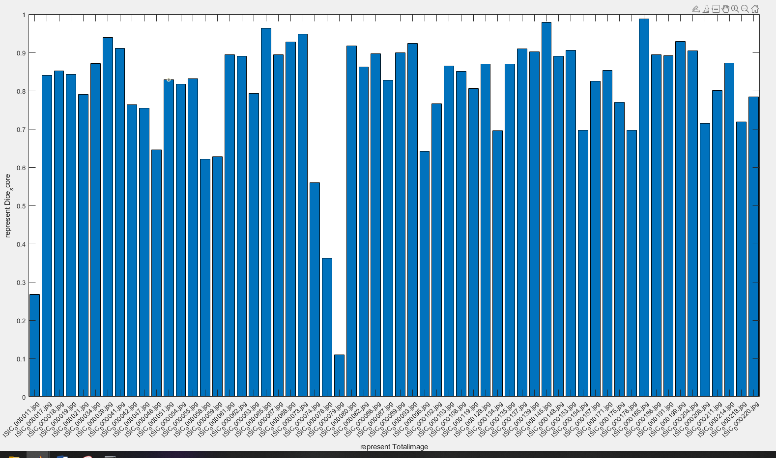

**Fig 3: Dice Similarity score versus Original Image**

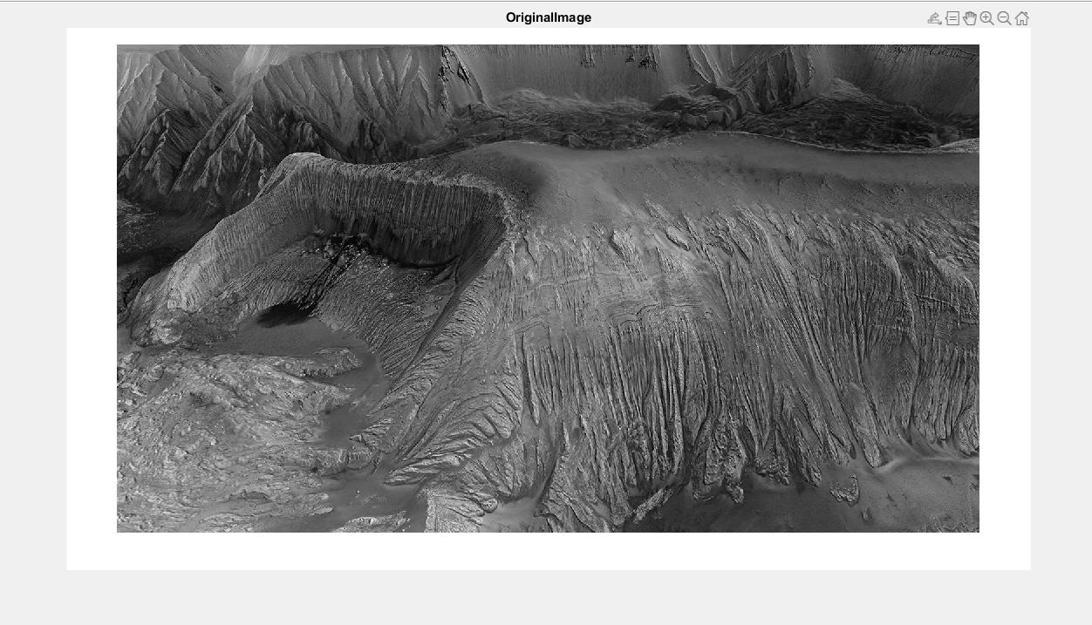

**Fig 4: READ THE IMAGE (ImgPIA.jpg)**

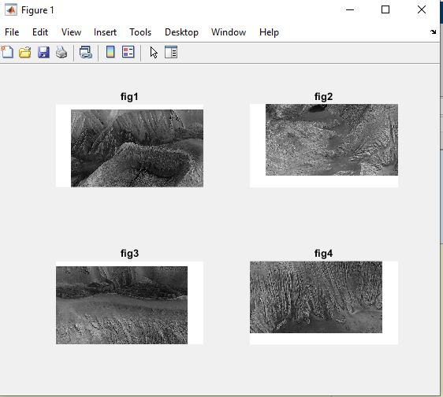

**Fig 5: SEGMENT INTO SECTION**

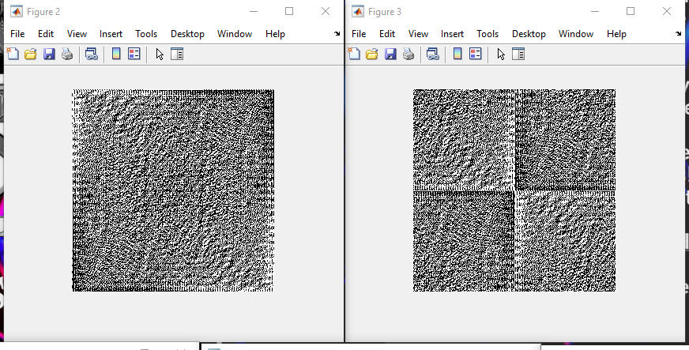

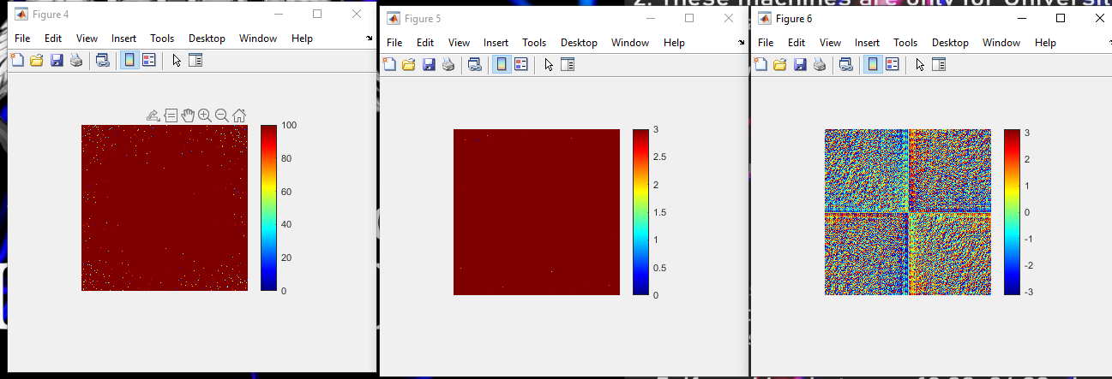

**Fig 6: WHEN INVERSE FOURIER TRANSFORM WAS FIRST APPLIED** Ans **= 5.158801618675188e+00, Ans = 10136717**

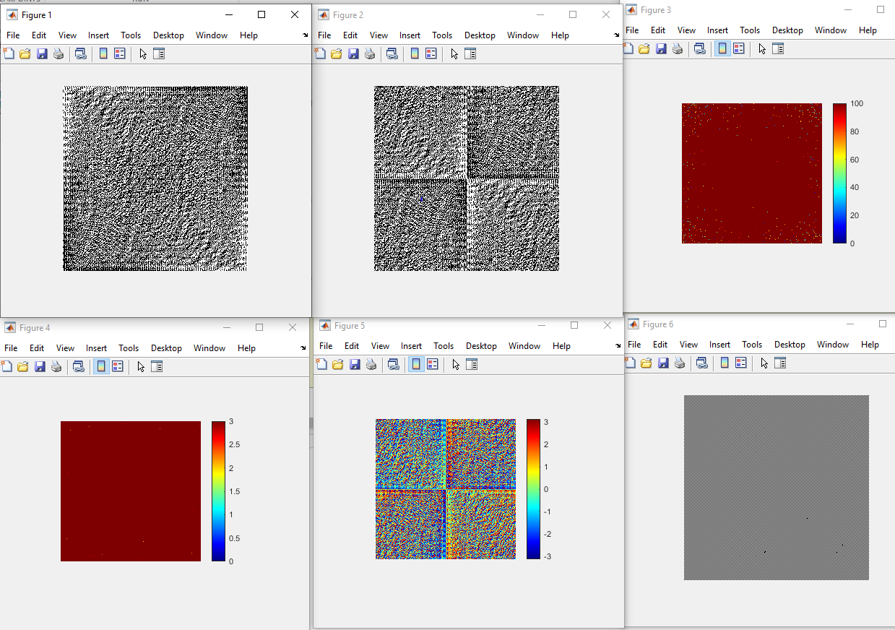

**Fig 7: WHEN FOURIER TRANSFORM WAS FIRST APPLIED** **Ans = 5.158801618675188e+00, Ans =** 10136717

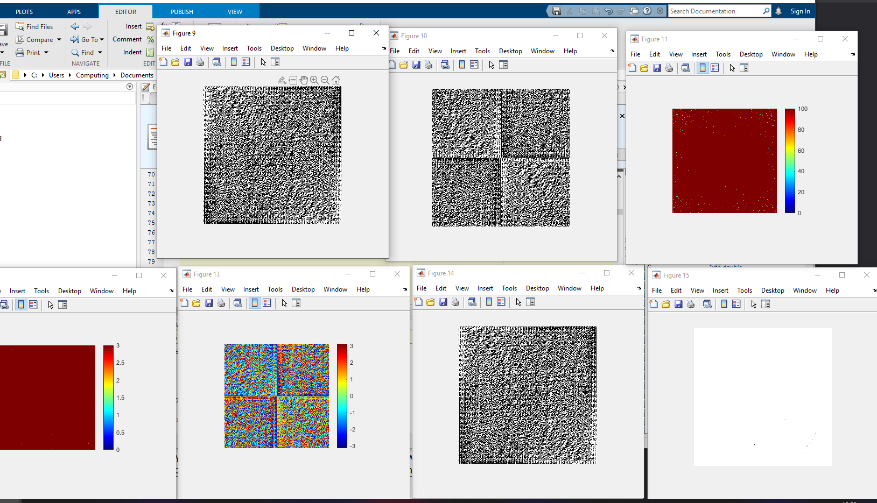

**Fig 8: WHEN BOTH FOURIER AND INVERSE FAST TRANSFORM WAS APPLIED** **Ans = 5.158801618675188e+00, Ans = 10136717**

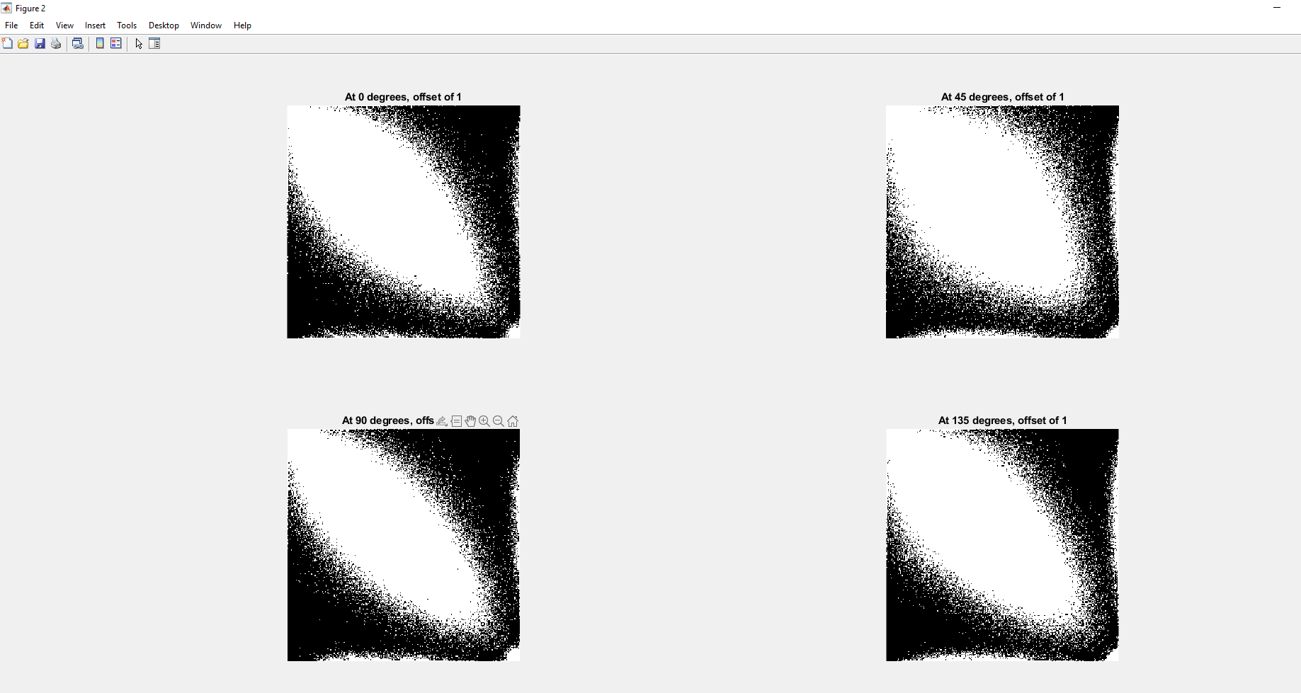

**Fig. 9: PARAMETER D AT 1 AT DIFFERENT ANGLE AND OFFSET**

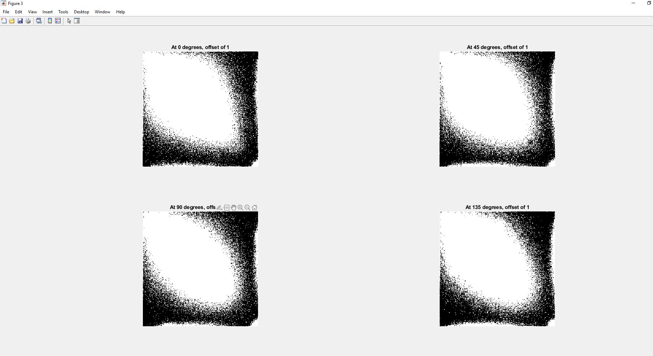

**Fig 10: PARAMETER D AT 2 AT DIFFERENT ANGLE AND OFFSET**

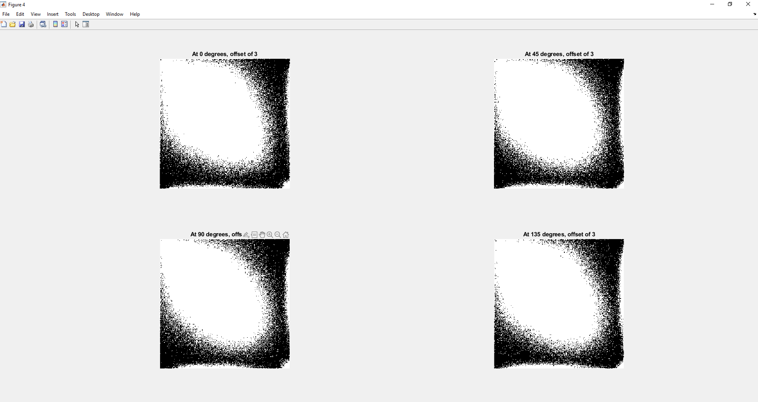

**Fig. 11 PARAMETER D AT 3 AT DIFFERENT ANGLE AND OFFSET**

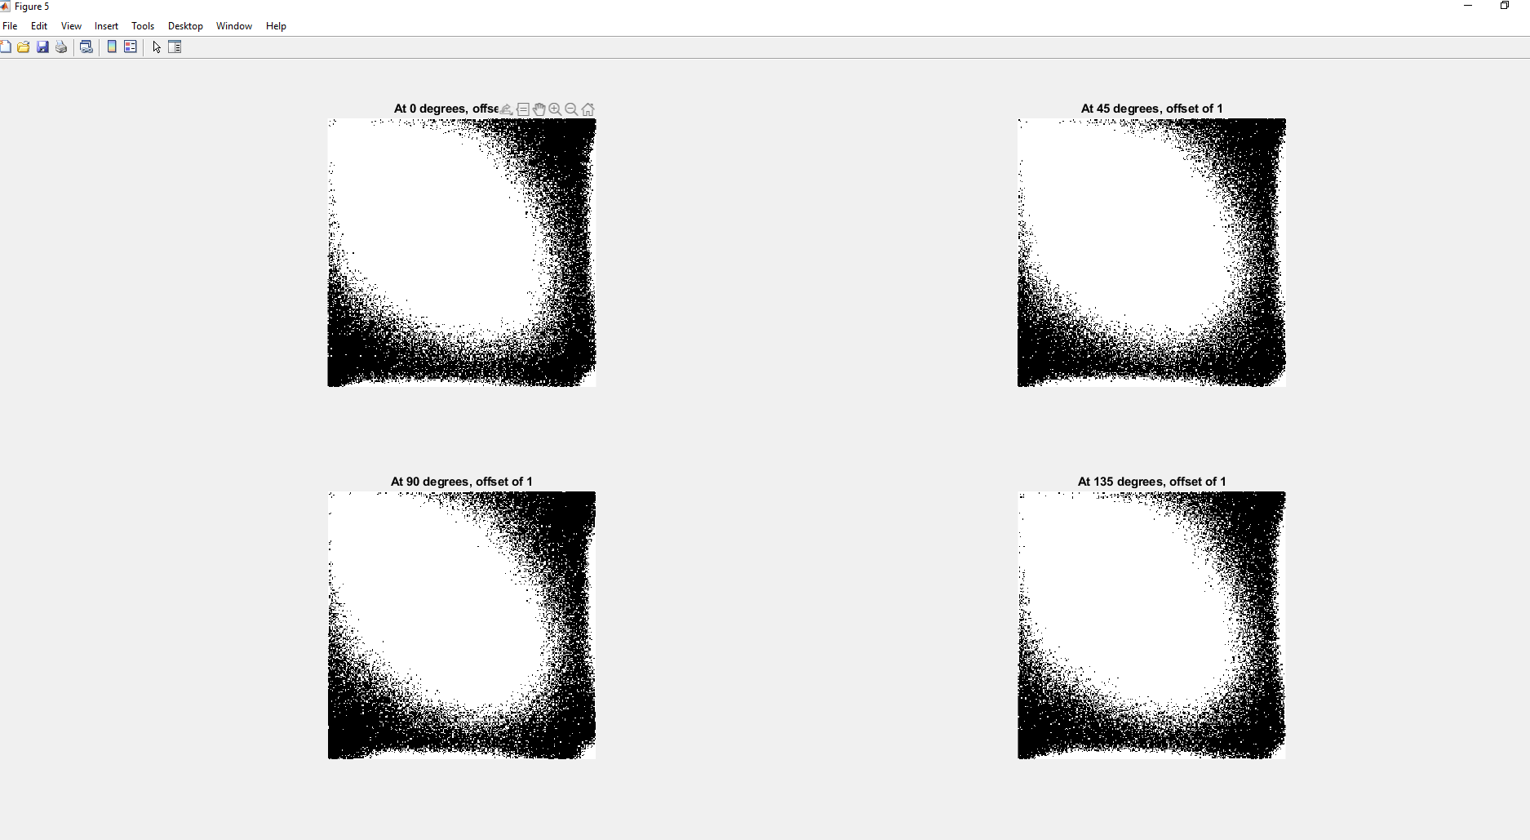

**Fig: 12 PARAMETER D AT 4 AT DIFFERENT ANGLE AND OFFSET**

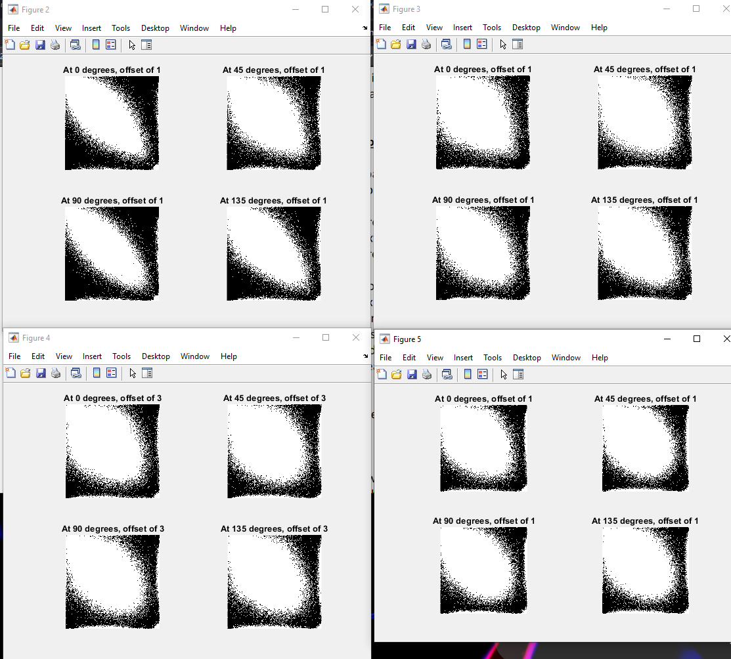

**Fig. 13:SELECT THE FEATURES FOR BOTH RADIUS AND DIRECTION AS DESCRIBE IN THE SPECTRAL APPROACH SESSION: FEATURES FOR ALL THE RADIUS AND DIRECTION**

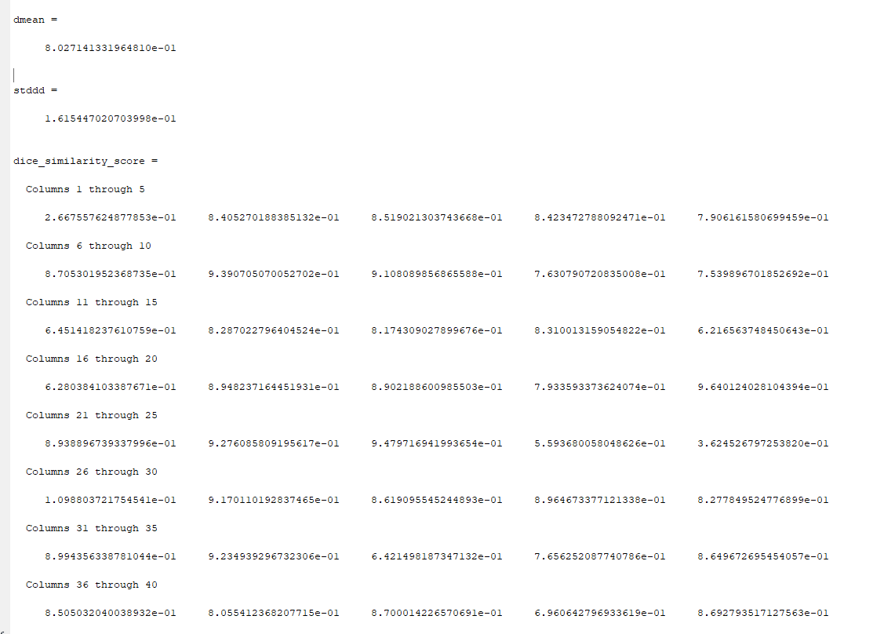

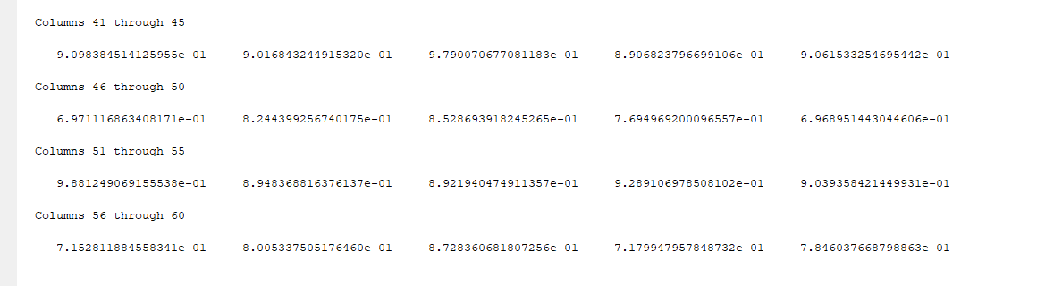

**Table 1: Dice Similarity score1 for the whole image**

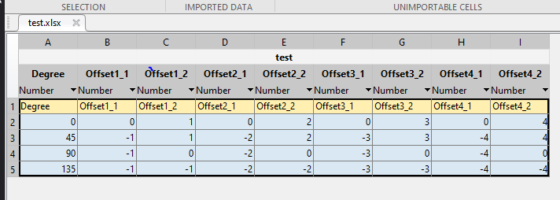

**Table 2: TABLE FOR FEATURES FOR BOTH THE RADIUS AND DIRECTION**